Name :- MAYANK KANNAMWAR
PRN No:- B25ME1027
Department :- E&TC

FUNCTION OVERLOADING

INPUT:
#include <iostream>
using namespace std;

class Calculator
{
public:

void add(int a, int b)

{
cout << "Sum of two numbers = " << a + b << endl;
}

void add(int a, int b, int c)
{
cout << "Sum of three numbers = " << a + b + c << endl;
}

void add(double a, double b)
{
cout << "Sum of two decimal numbers = " << a + b << endl;
}
};

int main()
{
Calculator c;
c.add(10, 20);
c.add(10, 20, 30);
c.add(10.5, 20.5);

return 0;
}

OUTPUT:
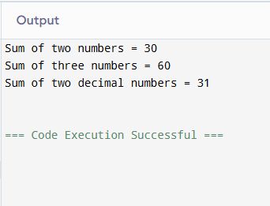

Input 2:
u#include <iostream>
using namespace std;

class Calculator
{
public:

void sub(int a, int b)
{
cout << "Difference of two numbers = " << a - b << endl;
}
void sub(int a, int b, int c)
{
cout << "Difference of three numbers = " << a - b - c << endl;
}
void sub(double a, double b)
{
cout << "Difference of two decimal numbers = " << a - b << endl;
}
};

int main()
{
Calculator c;
c.sub(10, 20);
c.sub(10, 20, 30);
c.sub(10.5, 20.5);

return 0;
}

Output:
